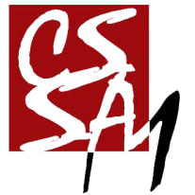

亲爱的 , 曼城学联将授予你 “2016-2017 年度优秀部员”称号,以兹鼓励。衷心感谢你对曼彻斯特中国学生学 者联谊会的辛勤付出。

This award is presented to ,  from The Department, on behalf of the CSSA-Manchester, would like to appreciate your contributions and extend our sincerest gratitude to you.

34th Chinese Students And Scholars Association of Manchester 2017.05.03

第 34 届曼彻斯特中国学生学者联谊会

Chinese Students And Scholars Association of Manchester

**2016-2017年度优秀部员**

The Outstanding Member of The Year