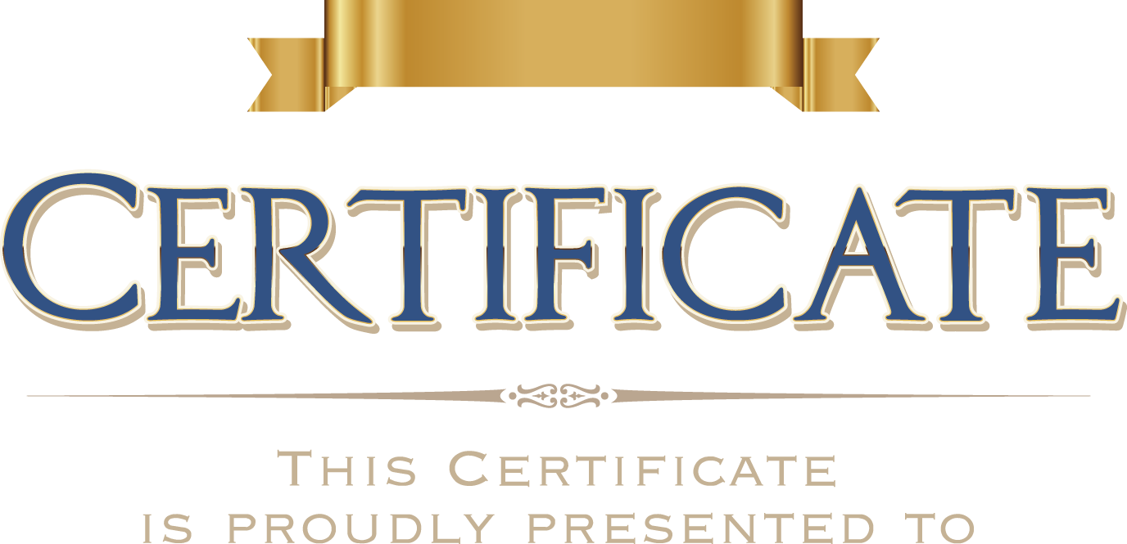

for winning the 1st place at the KAUST-Asia Wide Bandgap

Semiconductor Workshop held 28th Nov-3rd Dec 2019 at King Abdullah University of Science and Technology (KAUST).

Workshop Chairs Program Chair

Prof. Boon S. Ooi, Prof. Bo Shen Prof. Xiaohang Li, Prof. Hao-Chung Kuo