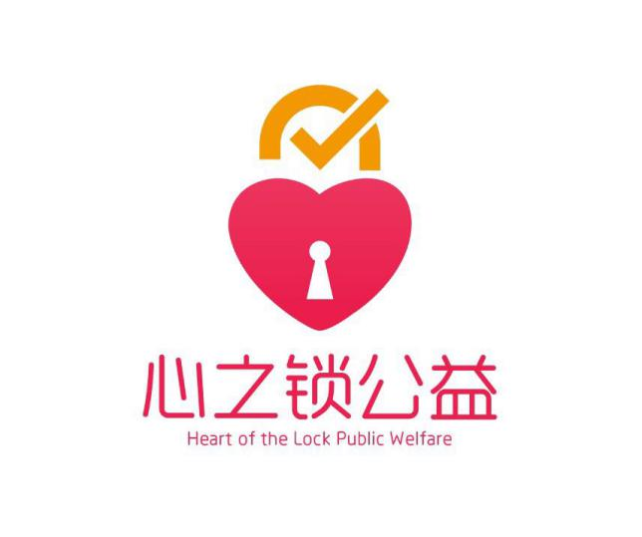

兹证明：

Hereby certify that:

______________（小姐/先生）参与了在贫困学校进行教育帮扶的短期9日支教活动，并获得志愿者工时共100小时。

______________ participated in the volunteer service which helps the poor students in the mountains, and do volunteer tutorial for them. This volunteer service lasted 9 days and this lady/gentleman gained 100 volunteer hours for this service.

该（小姐/先生）在此次活动中工作表现出色。

This lady/gentleman showed effort in this service, participated with passion and hard work.

心之锁公益及学校，当地教育机构特发此证，以表示感谢和鼓励。

Heart of the Lock Public Welfare, the school and the local education institutions present this certificate as an encouragement and appreciation.

CERTIFICATE FOR VOLUNTEER

SERVICES OF HEART OF THE LOCK PUBLIC WELFARE

心之锁公益活动志愿者服务证明

__________________________________

2018年10月

心之锁公益