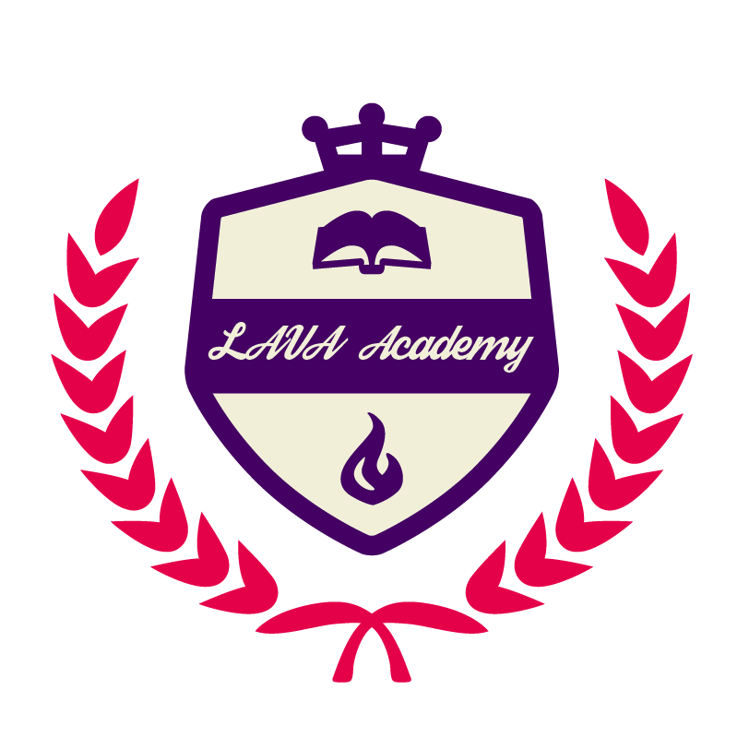·

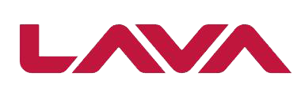

Therefore,*we are very pleased to announce that you have been chosen as a*

**"LAVA STAR OF THE YEAR 2018 Middle East".**

*We appreciate your work. A big thank you from LAVA Team.*

Jelly Mao

General Manager - Middle East

*You have done a great job for LAVA！*

*We want you to know that your hard work and dedication has been acknowledged.*

*This positive attitude is helping LAVA to reach our targets & goals.*